Experiment 2

Student Name: Aradhya Sharma UID: 25MCC20042
Branch: MCA (CCD) Section/Group: 25MCC-101A
Semester: 2 Date of Performance: 21 jan 2026

Subject Name: Technical training Subject Code: 25CAP-652

Implementation of SELECT Queries with Filtering, Grouping, and Sorting in PostgreSQL

AIM
To implement and analyze SQL SELECT queries using filtering, sorting, grouping, and aggregation concepts in PostgreSQL for efficient data retrieval and analytical reporting.

OBJECTIVES
- To retrieve specific data using filtering conditions
- To sort query results using single and multiple attributes
- To perform aggregation using grouping techniques
- To apply conditions on aggregated data
- To understand real-world analytical queries commonly asked in placement interviews

STEP 1: Database and Table Preparation

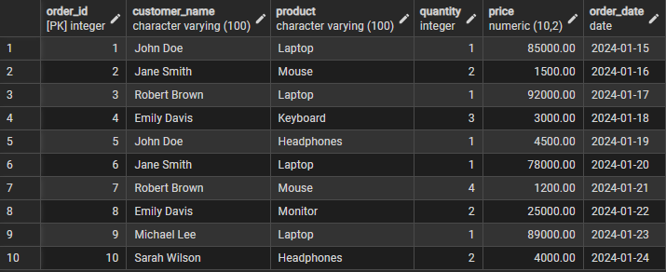
Created a realistic dataset with 10 records suitable for analytical queries.

STEP 2: Filtering Data Using Conditions

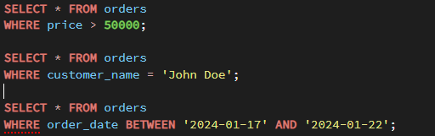

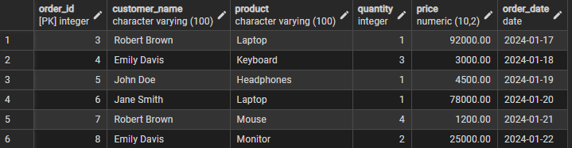

STEP 3: Sorting Query Results

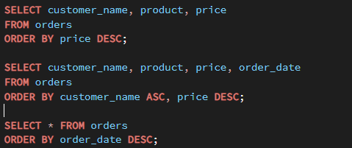

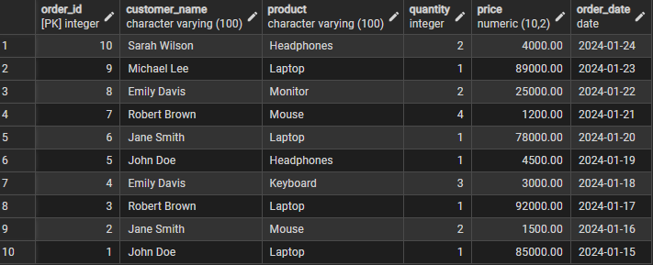

STEP 4: Grouping Data for Aggregation

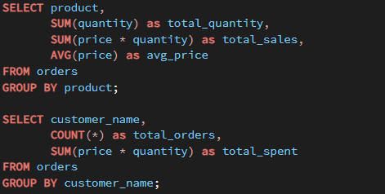

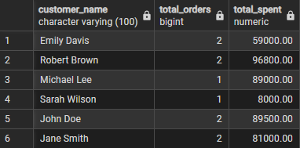

STEP 5: Applying Conditions on Aggregated Data

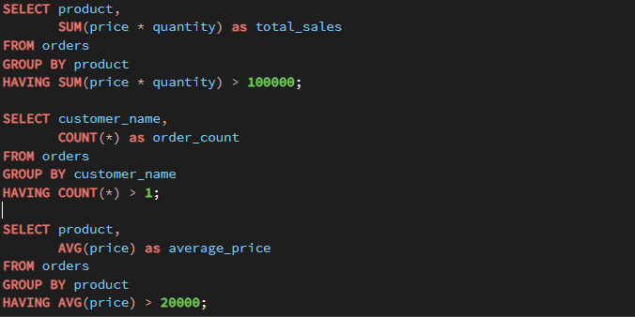

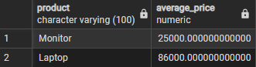

STEP 6: Conceptual Understanding – WHERE vs HAVING

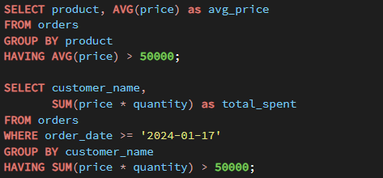

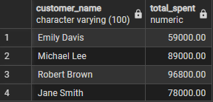

STEP 7: Real-World Analytical Query Examples
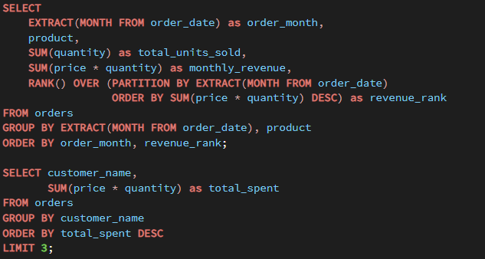
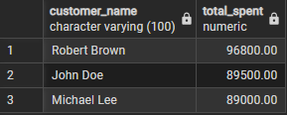

LEARNING OUTCOMES
- Filtering Skills: Learned to retrieve relevant records using the WHERE clause with various conditions.
- Sorting Techniques: Understood ordering results using ORDER BY with single and multiple columns.
- Grouping & Aggregation: Gained proficiency in summarizing data using GROUP BY with aggregate functions such as SUM, AVG, and COUNT.
- Conditional Aggregation: Clearly differentiated between WHERE (row-level filtering) and HAVING (group-level filtering).
- Real-World Application: Built confidence in writing analytical SQL queries used in dashboards and business reports.
- Interview Readiness: Prepared for SQL placement questions on filtering, grouping, aggregation, and analytical functions.

